## WEB TECHNOLOGIES (4.5CA152C01)

## **ASSIGNMENT - 1**

Q1. Construct the following HTML page using different HTML tags.

* **Code :**

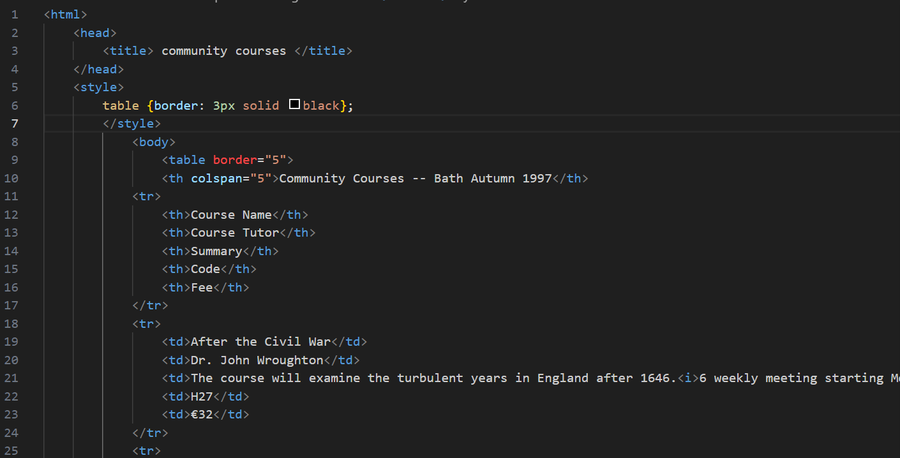

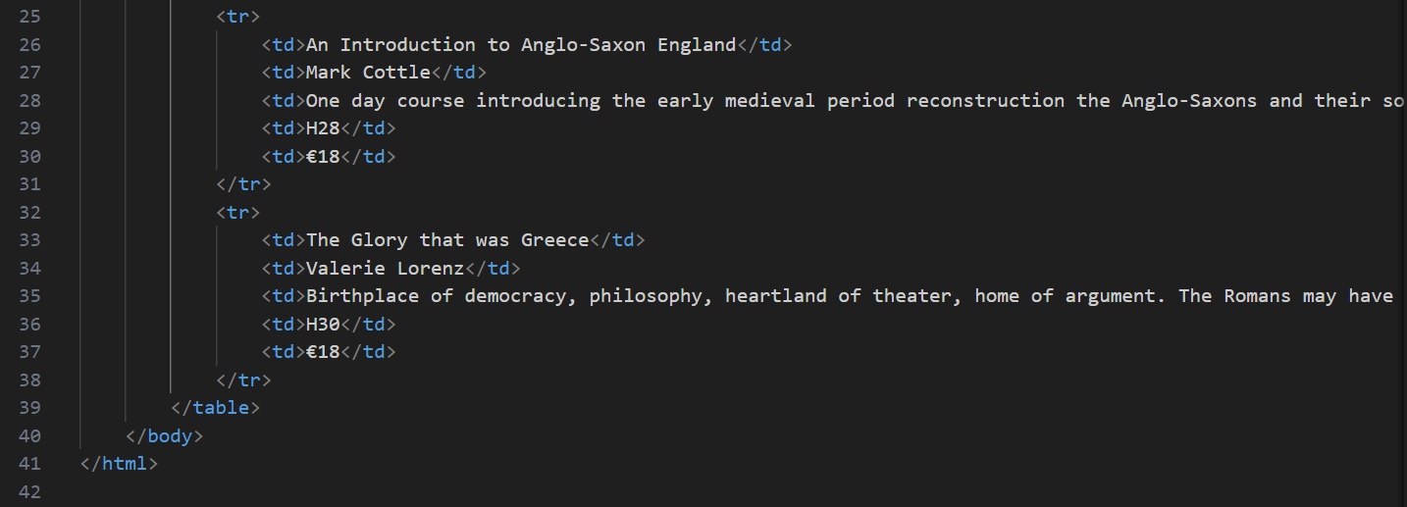

**OUTPUT :**

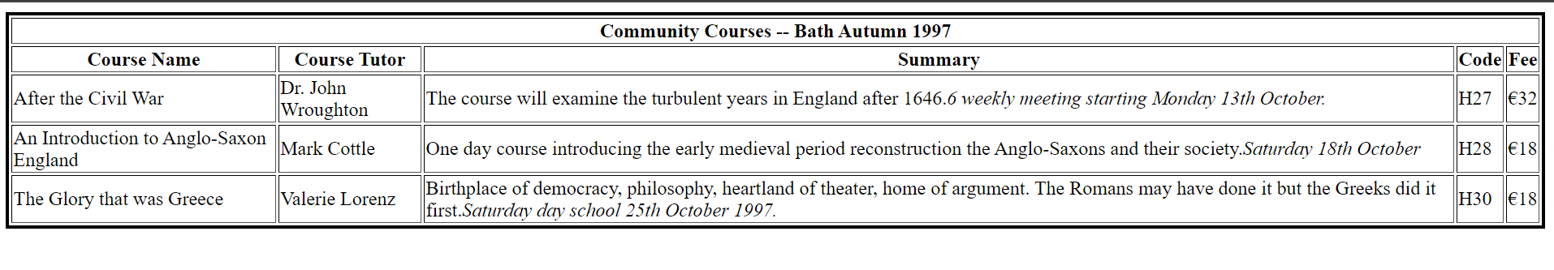

Q2. A hyperlink, also called a link or web link, contains an address for a destination and acts as a reference to data. A user can easily follow, jump to, and be directed to the destination by either clicking, tapping on or hovering over the link.

* Types of Hyperlinks :

1. External Links : these links point to pages on different websites (to direct users to other websites for more information or resources.)
2. Internal Links : these links connect to other pages within the same website or domain (navigation within the same website, such as linking to the “about us” or “contact” pages.)
3. Anchor Links (in-page links) : these links jump to a specific section on the same page, using an ID attribute (useful for long pages, allowing users to quickly navigate to different sections (like a table of contents.)
4. Email Links : this type of link opens the user’s default email client to send an email when clicked (for making it easy for users to contact via email without copying the email address.)
5. Telephone Links : this link allows users to directly dial a number (especially on mobile devices) (ideal for websites with contact information, making it easier for mobile users to call directly.)
6. Download Links : these hyperlinks prompt the user to download a file instead of navigating to another web page (for providing downloadable resources like PDFs, images, documents, etc.)
7. Image Links : an image can be made into a clickable hyperlink (enhances the visual appeal of a site by allowing images to act as links instead of just text.)

Q3. Change the background color of the page. At the bottom create a link to take the user to the top of the page and vice versa.

<html>

    <head>

        <title>scrolling from top/bottom</title>

    </head>

        <body style="background-color: deepskyblue;">

            <a href="#bottom">bottom page</a>

            <h1> GOOD MORNING </h1>

            <p> An example to see how we'll scroll to the top/bottom of the page </p>

            <div style="height: 1000px; width: 100%; background-color: deeppink;"></div>

            <h2 id="bottom">YOU ARE AT THE BOTTOM PAGE!</h2>

            <a href="#top">top page</a>

        </body>

</html>

**OUTPUT:**

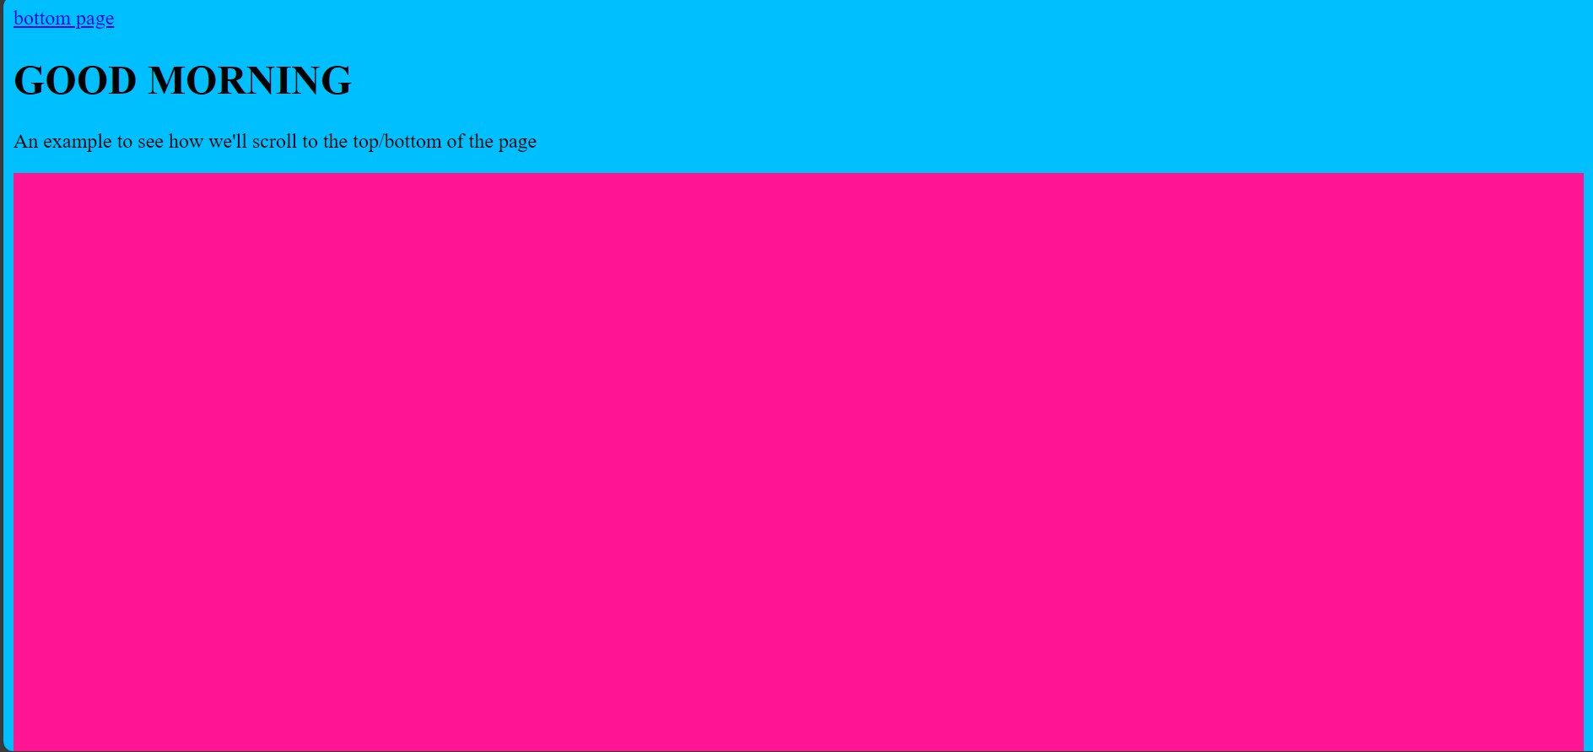

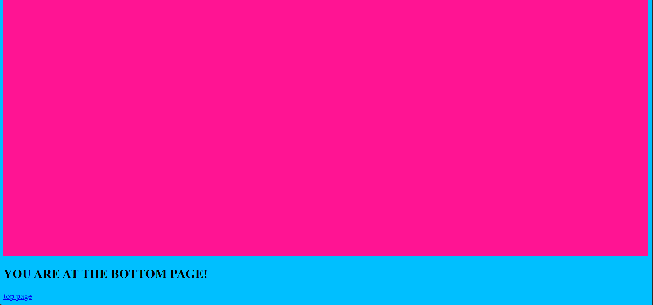

Q4. Compare different tags used in HTML table while creating any web page.

* (1) <table> : defining the table

1. <tr> : defining the row
2. <td> : defining the data cells
3. <th> : defining the header cell
4. <caption> : to add a title to the table

<html>

<head>

<title> Different tags used in HTML </title>

</head>

<body>

<style>

table {border : 3px solid black };

</style>

<table border =”5”>

<caption> Flowers Sales </caption>

<tr>

<th>Flowers</th>

<th>Sales cost</th>

<th>Delivery</th>

</tr>

<tr>

<td>Hibuscus<td>

<td>390</td>

<td>2-3 days</td>

</tr>

<tr>

<td>Rose</td>

<td>250</td>

<td>1-2 days</td>

</tr>

<tr>

<td>Tulip</td>

<td>360</td>

<td>2-4 days </td>

</tr>

</table>

</body>

</html>

**OUTPUT:**

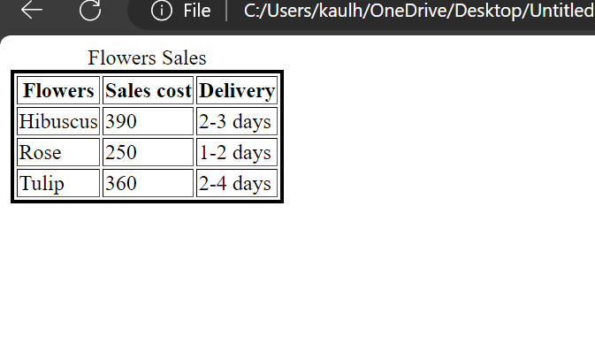

Q5. Make up a table of data. Your table must have at least four rows and four columns. It must have at least one rowspan and one colspan specifier. (and yes, the attributes value must be greater than one).

<html>

<head>

<title>Class Schedule</title>

</head>

<body>

<table border="1">

<caption>Class Schedule</caption>

<tr>

<th>Time</th>

<th>Monday</th>

<th>Tuesday</th>

<th>Wednesday</th>

</tr>

<tr>

<td>8:50-9:40</td>

<td>Maths</td>

<td>DBMS</td>

<td>ITPC</td>

</tr>

<tr>

<td>9:40-10:30</td>

<td colspan="2">WT</td>

<td>Library</td>

</tr>

<tr>

<td>10:30-11:20</td>

<td rowspan="2">IKS</td>

<td>Maths(tut)</td>

<td>ITPC Lab</td>

</tr>

<tr>

<td>11:20-12:10</td>

<td>Library</td>

<td>SDG</td>

</tr>

</table>

</body>

</html>

**OUTPUT:**

